**Interview Test**

Consider the dynamics given below:

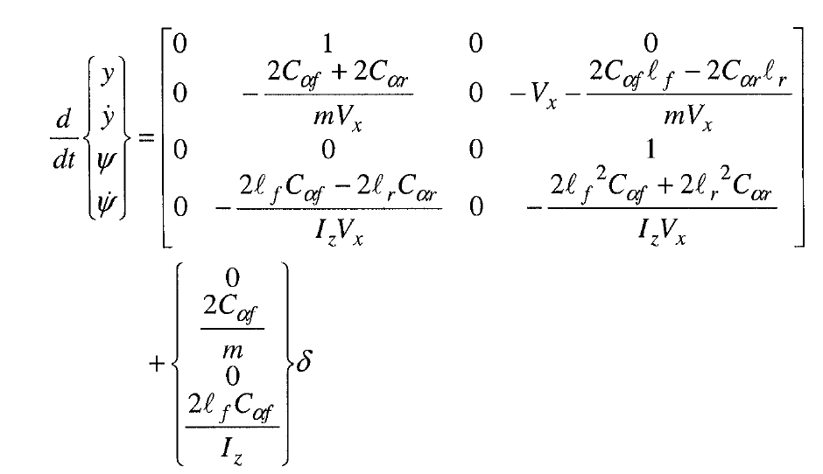

Where, {y, ydot, psi, psidot} represent the following: y represents the y coordinate of the vehicle in inertial frame, ydot represents the y-component of the velocity and psi represents the heading angle and psidot represents the yaw-rate. The control effort in this model is given by “delta” i.e., the steering angle of the front wheel. The constants used in this simple linear model are stiffness constants, moments of inertia, length of front and rear axle from CG and surge velocity.   
Answer the following question:

1. What must be your control effort “delta”, such that the actual yaw rate of the vehicle becomes equal to the target yaw rate of 2 deg/s. Hint: You can use any known AI-based control technique to obtain the control effort. I want to see the Matlab/Simulink implementation along with graphs for all the states and control effort. If you do not know how to implement it in Matlab or Simulink then you may use Python.
2. What can you comment on the stability of the aforementioned control law. Hint: use Lyapunov’s direct method or one of its variants to comment on the stability, i.e., if the aforementioned control law would yield a “non-increasing” sequence of Lyapunov function.
3. Develop a control scheme to track a path with radius of curvature equal to 40m. Hint: The relation between target radius of curvature and target yaw rate is given by: (psi_dot_des = Vx/R), where R is the target radius of curvature (in this case R = 40m) and Vx is the forward velocity of the vehicle.

The physical constants used in this example are:

Calpha_f = 100000;

Calpha_r = 126000;

m = 2325; Iz = 4132; lr = 2; lf = 2; Vx = 10m/s